**FUNCTIONAL AND TECHNICAL COMBINED DOCUMENTATION**

**Page2 (New Portfolio – Portfolio Details): (Front End Url:**<http://35.200.128.183:8088/page1/Page2>)

**Functional Picture:**

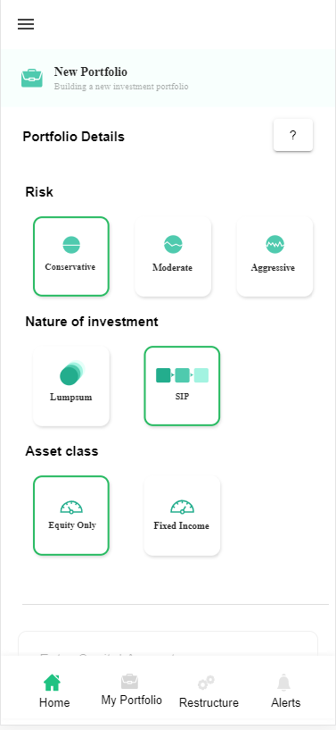

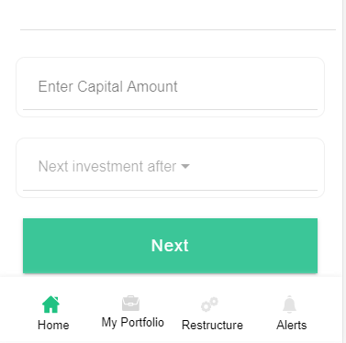

**Technical Explanations (Front End and Back End):**

**In Page1.tsx, Please see the below two code snippets:**

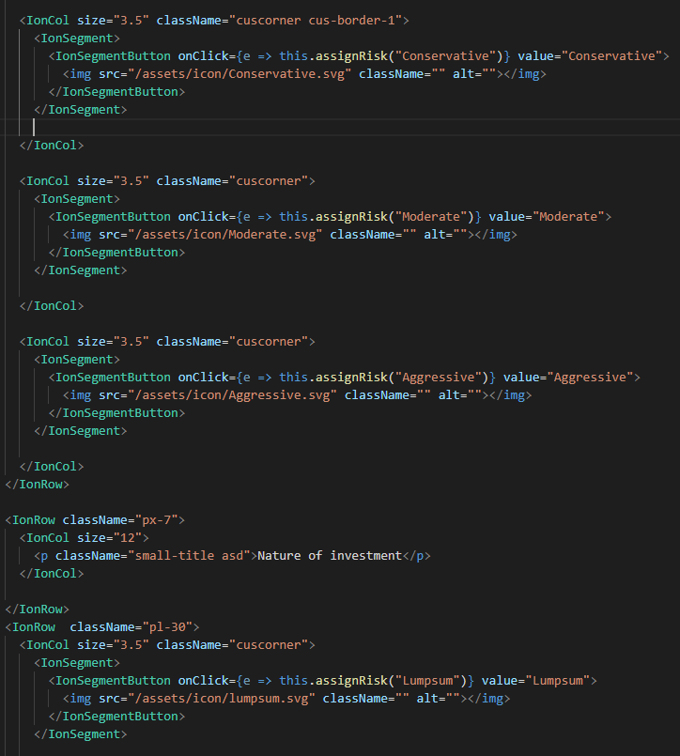

**In the above code snippet, you can see that we have used IonSegment and IonSegmentButton to make the <img> tag clickable and we are saving the click event values in the variables with the help of assignRisk () function. After that we are doing post request with the help of those variables (Conservative, Moderate, Aggressive,) We are doing this for “Risk”, “Nature of Investment” and “Asset class”. Please see the below given code.**

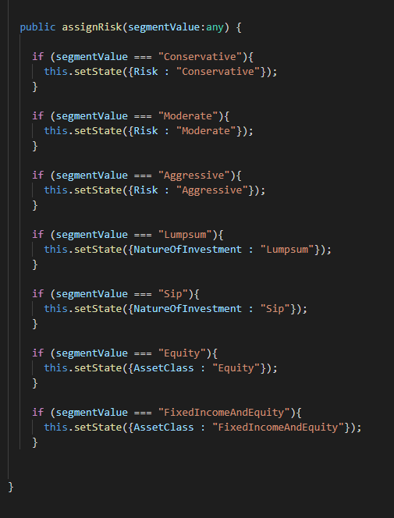

**For “Enter Capital Amount” and “Next Investment After”, we are normally putting the value and doing the post request.**

**Now Let’s look at our function which performs the POST request.**

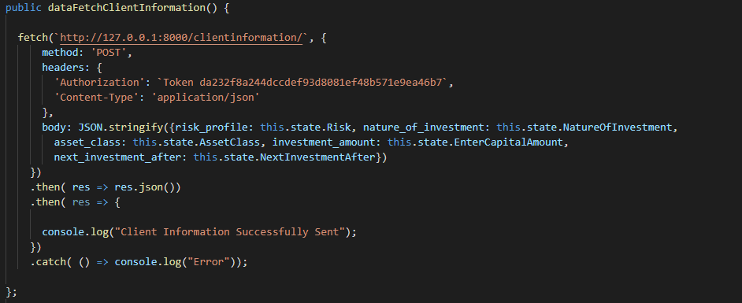

**As you can see above, there is one url:**

[**http://127.0.0.1:8000/clientinformation/**](http://127.0.0.1:8000/clientinformation/) **--🡪** This url calls **ClientInformationAPI** which with the help of **ClientInformationSerializer** saves the data into the **ClientInformation** model Database in the post method. Please see the below code snippets of **1)** **ClientInformationAPI, 2) ClientInformationSerializer and 3) ClientInformation model.**





